Emerging Architectures for LLM Applications
https://a16z.com/2023/06/20/emerging-architectures-for-llm-applications/

Pre-trained AI models - most important architectural change in software since the internet. Individual developers build AI apps in days vs. months for supervised ML projects done by big teams.
LLMs - powerful new primitive for building software. New and different from before ==> their use is not obvious. The tools in this article are likely just the starting point (will evolve) and are based on conversations with startup leaders including Andrej Karpathy.

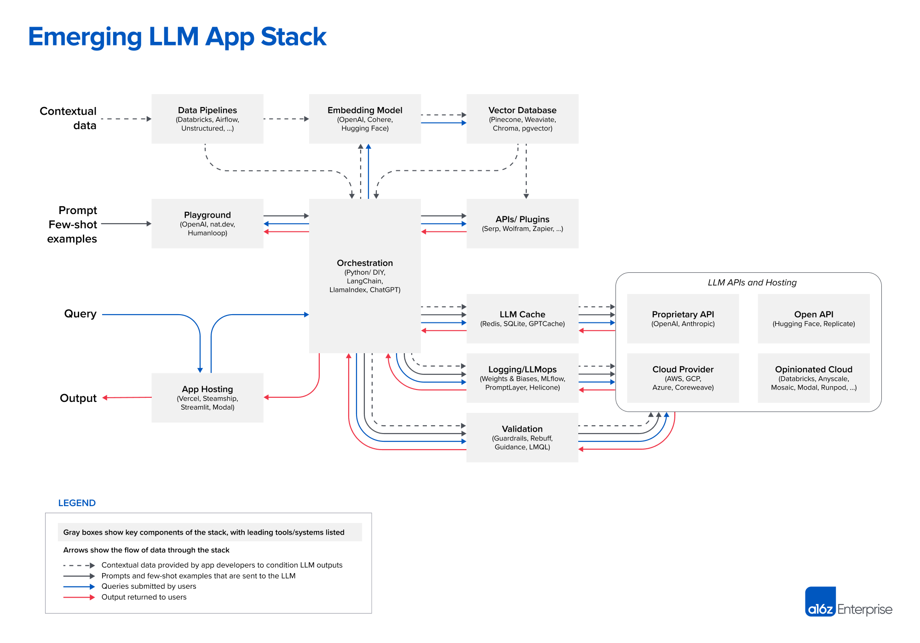

Links to each project for quick reference:
Data pipelines | Embedding model | Vector database | Playground | Orchestration | APIs/plugins | LLM cache
Databricks | OpenAI | Pinecone | OpenAI | Langchain | Serp | Redis
Airflow | Cohere | Weaviate | nat.dev | LlamaIndex | Wolfram | SQLite
Unstructured | Hugging Face | ChromaDB | Humanloop | ChatGPT | Zapier | GPTCache
 |  | pgvector

Logging / LLMops | Validation | App hosting | LLM APIs (proprietary) | LLM APIs (open) | Cloud providers | Opinionated clouds
Weights & Biases | Guardrails | Vercel | OpenAI | Hugging Face | AWS | Databricks
MLflow | Rebuff | Steamship | Anthropic | Replicate | GCP | Anyscale
PromptLayer | Microsoft Guidance | Streamlit |  |  | Azure | Mosaic
Helicone | LMQL | Modal |  |  | CoreWeave | Modal
 |  |  |  |  |  | RunPod

Different ways to build with LLMs:
- training from scratch,
- fine-tuning,
- using hosted APIs.

In-context learning (mostly used design pattern)
Use LLMs off the shelf (no fine-tuning) + control their behavior through clever prompting and contextual data / few shot examples. Example: chatbot for Q&A on a set of legal documents. Showing all docs to LLM doesn’t scale (context window) - sends only a handful of the most relevant documents (determined by LLMs).

Three phases:
- Data preprocessing / embedding: storing data (e.g. legal documents) to be retrieved: docs broken into chunks, passed through embedding model, stored in a vector database.
- Prompt construction / retrieval: user submits a query (e.g. a legal question), app constructs prompt template + few-shot examples + any info from external APIs + set of relevant docs from vector database.
- Prompt execution / inference: prompts submitted to LLM for inference. Developers can add operational systems: logging, caching, and validation.
Easier than training / fine-tuning LLM: don’t need a team of ML engineers or to host your own infrastructure (expensive dedicated instance), reduces an AI problem to a data engineering problem.

Big question for ICL: what happens if the context window increases? Comes with tradeoffs - cost and time of inference scale quadratically – may be cost-prohibitive: GPT-4 can cost hundreds of dollars for a large dataset.

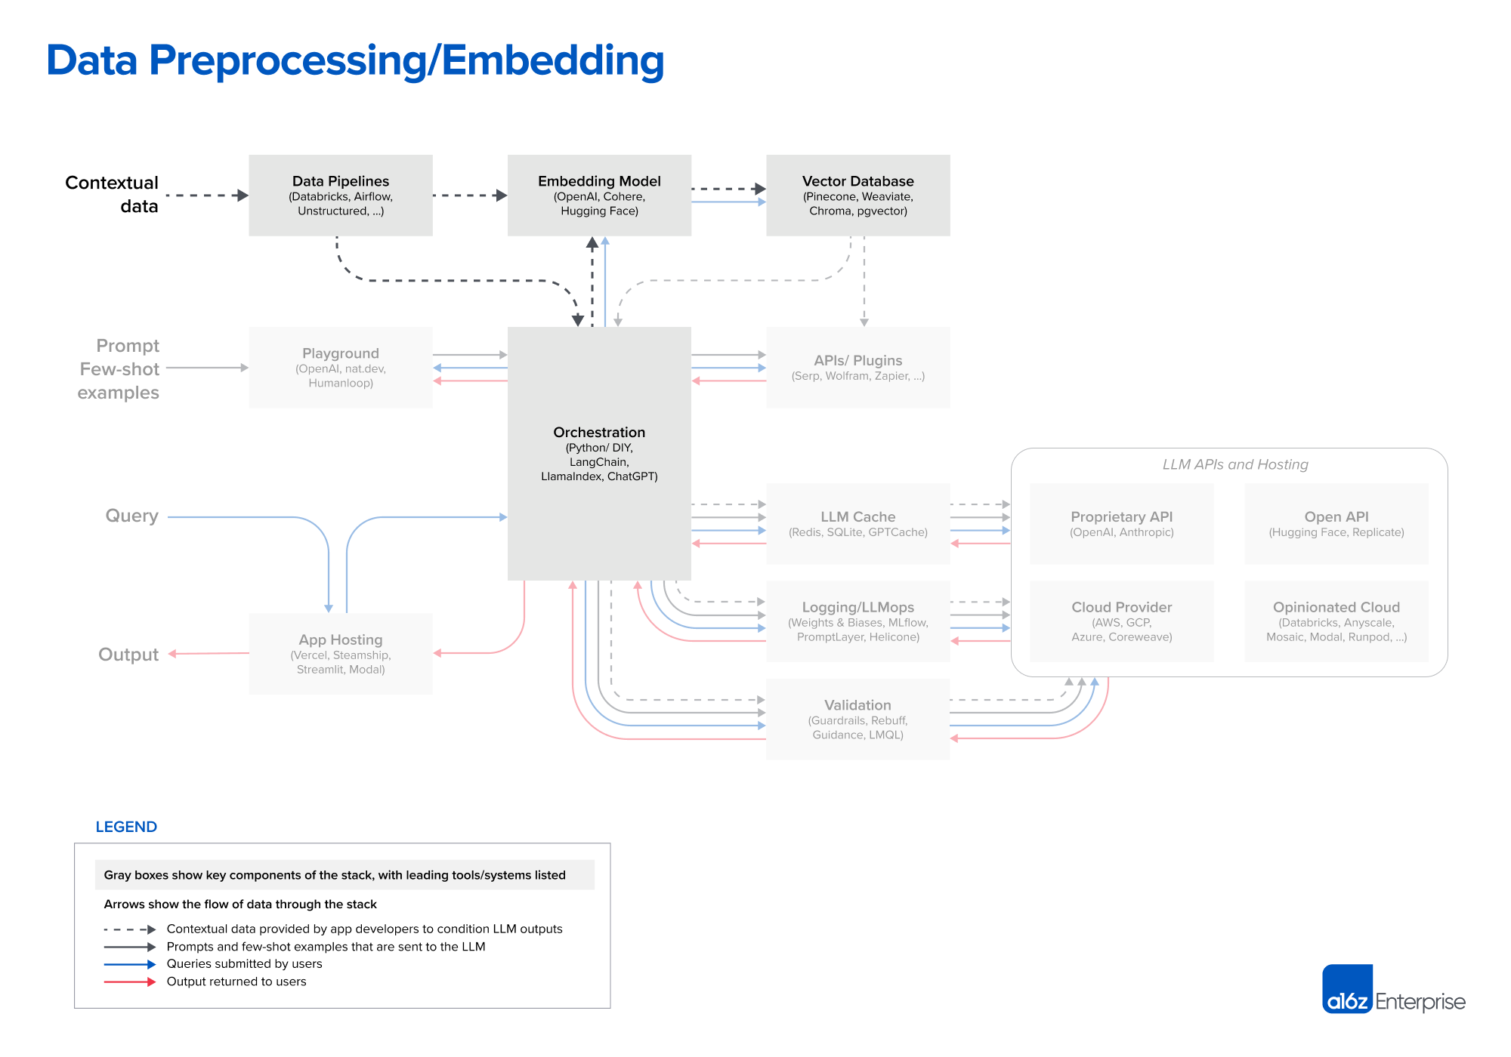
Contextual data for LLM apps - text documents, PDFs, structured CSV or SQL tables. Data-loading is through ETL tools or using document loaders built into orchestrators like like LangChain and LlamaIndex. For embeddings, most developers use the OpenAI API for text-embedding-ada-002 model: easy to use, good results, becoming increasingly cheap. Also Cohere - better performance in certain scenarios. In the open-source realm - Sentence Transformers SBERT.

From a systems standpoint, most important piece of preprocessing pipeline - vector database: efficiently storing, comparing, and retrieving up to billions of embeddings. Default go to in the market - Pinecone: fully cloud-hosted, easy to get started with, has many production features OOTB (performance at scale, SSO, uptime SLAs).

There’s a huge range of vector databases available:
- Single-node: Weaviate, Vespa, Qdrant - tailored for specific applications.
- Local libs: Chroma and Faiss: easy to spin up for small apps and experiments. May not substitute for a full database at scale.
- OLTP extensions like pgvector: good option if you try to use Postgres, or for enterprises who buy most of their data infrastructure from a single cloud provider.

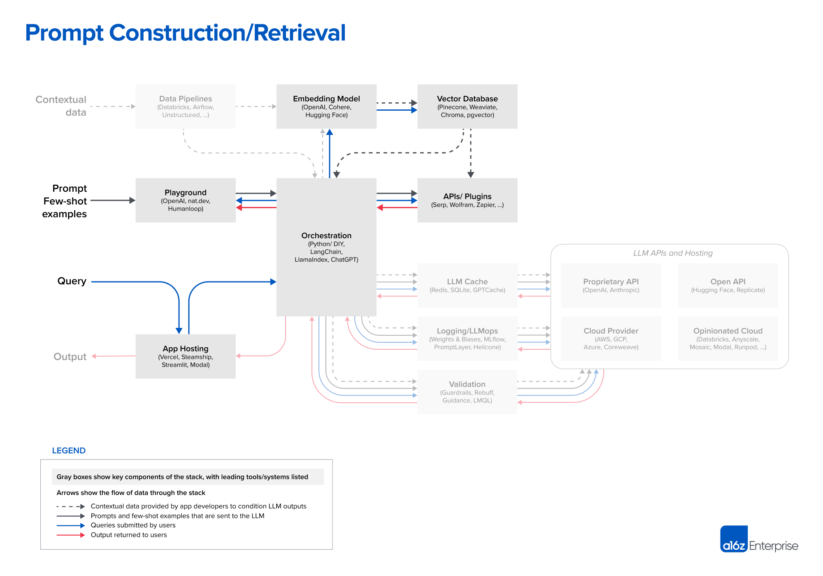
- Prompting becoming complex – zero-shot / few-shot learning: good results, but need better accuracy.
- Grounding model in ground truth and external context thru advanced prompting: chain-of-thought, self-consistency, generated knowledge, tree of thoughts, directional stimulus, many others.

Orchestration frameworks like LangChain and LlamaIndex shine - abstract away many details of prompt chaining; interface with external APIs; retrieve contextual data from vector databases; and maintain memory across multiple LLM calls; provide templates for common apps. Output – prompt(s) for LLMs. LangChain – leader. LangChain new (v. 0.0.201), but popular and in prod. Using raw Python for this is on decline.

ChatGPT, as an API, can perform orchestration: abstracting away the need for prompts; maintaining state; retrieving contextual data via plugins, APIs, etc. It may become a simple alternative to prompt construction.

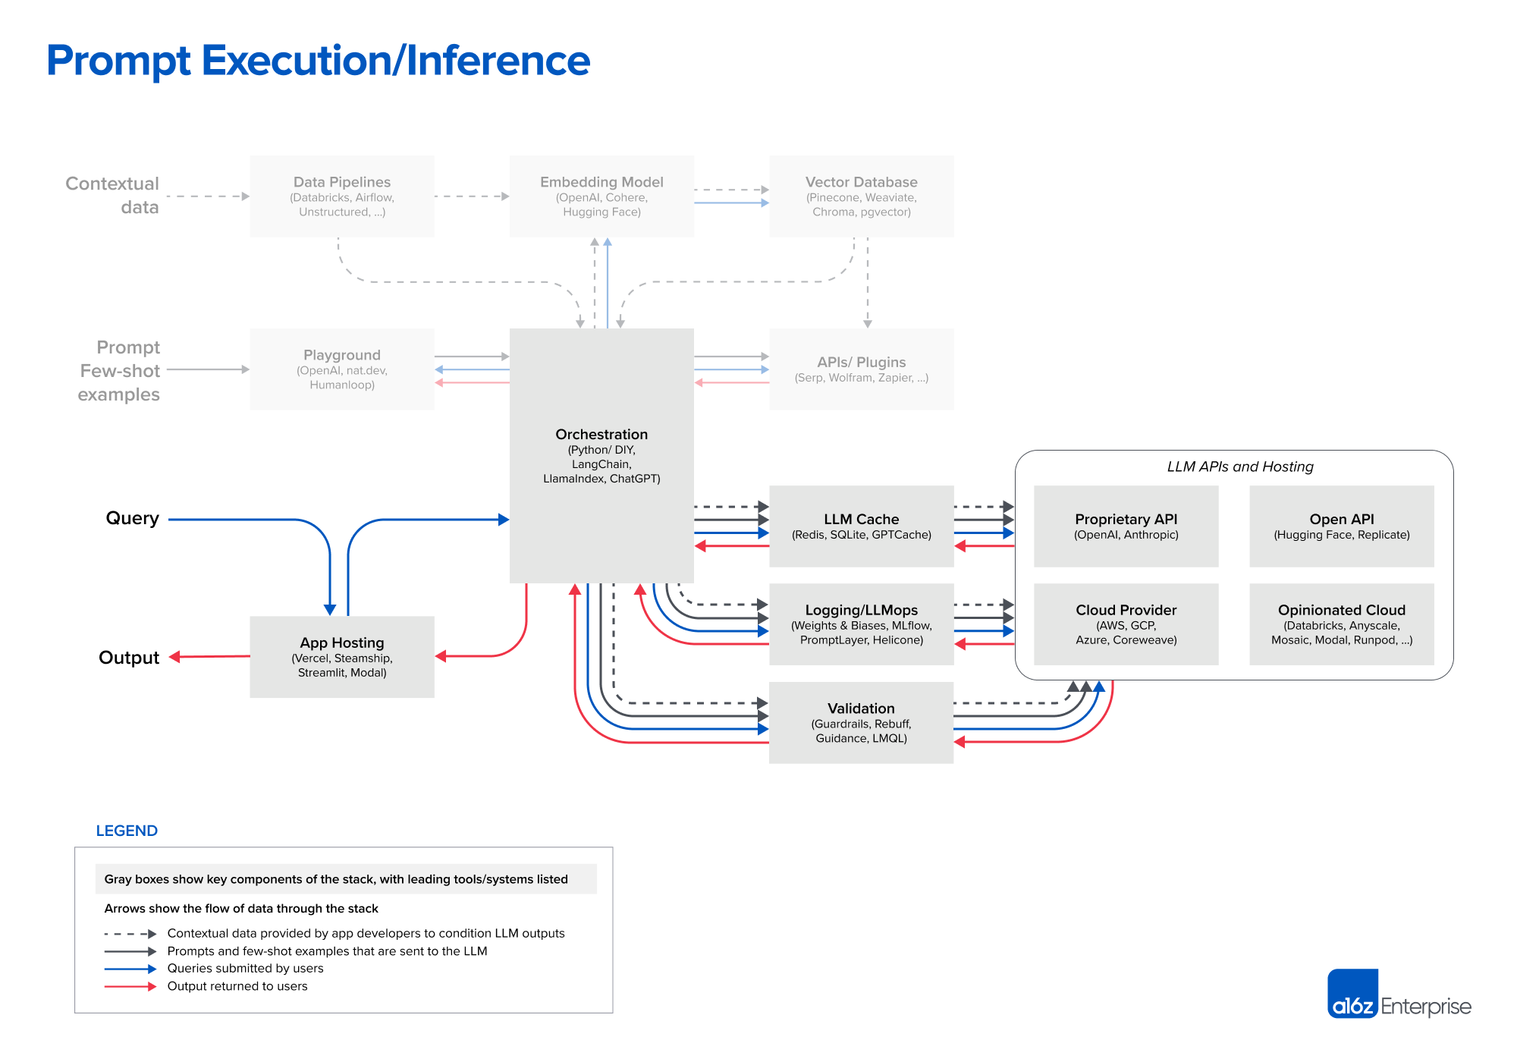
Most developers start with gpt-4 (gpt-4-32k), then switch to gpt-3.5-turbo when project matures (~50x cheaper and significantly faster) OR experiment w/other vendors (Anthropic), triage some requests to open-source models, fine-tuning open-source models. Open-source models are closing the availability and performance gap (e.g. LLaMa 2). A variety of inference options are available for open source models, including simple API interfaces from HuggingFace and Replicate; raw compute resources from the major cloud providers.

LLM operational tooling is not developed deeply yet. Caching is common - improves response times and cost: usually based on Redis. Tools like Weights&Biases and MLflow (traditional ML) or PromptLayer and Helicone (built for LLMs) – log, track, and evaluate LLM outputs, usually to improve prompt construction, tuning pipelines, or selecting models. There are new tools to validate LLM outputs (e.g., Guardrails), detect prompt injection attacks (e.g., Rebuff).

Hosting LLMs:
- Cloud platform as a service (Vercel)
- Major cloud providers
- Two new categories: a) end-to-end hosting for LLM apps w/orchestration (LangChain), multi-tenant data contexts, async tasks, vector storage, and key management (startups like Steamship); b) hosting models and Python code in one place (companies like Anyscale and Modal).

Special topic: AI agent (not covered above). AutoGPT – popular on Github. Developers are incredibly excited. Agents have a huge potential. But, agents are still in the proof-of-concept phase.

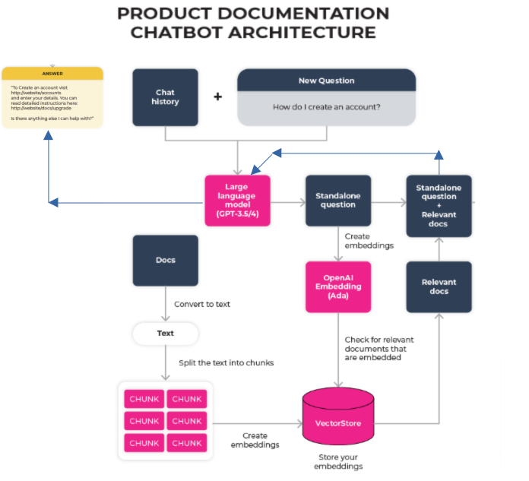

LLMOps
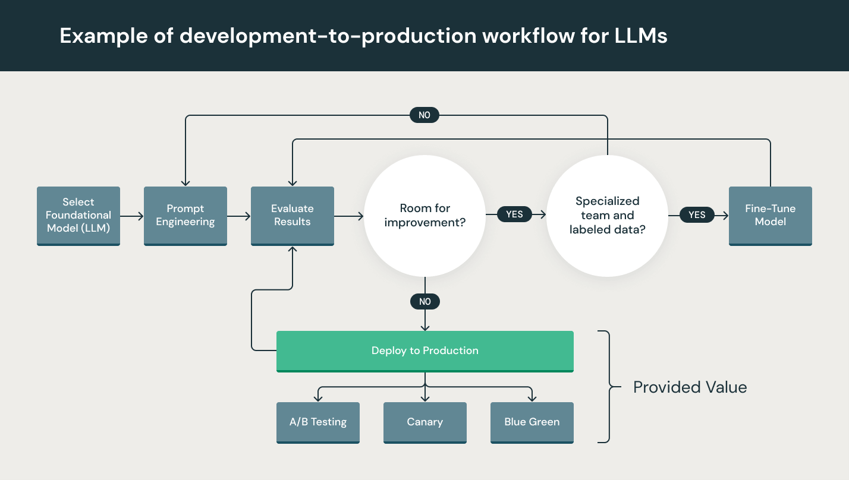

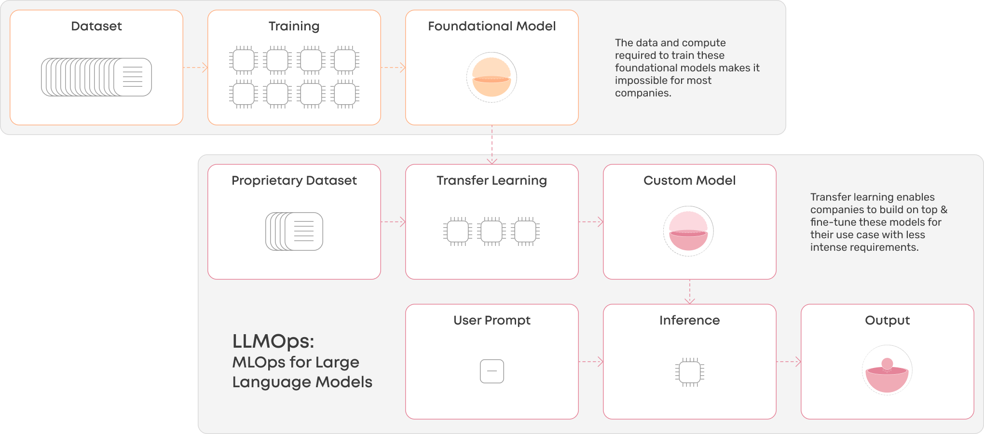

Imitation Learning
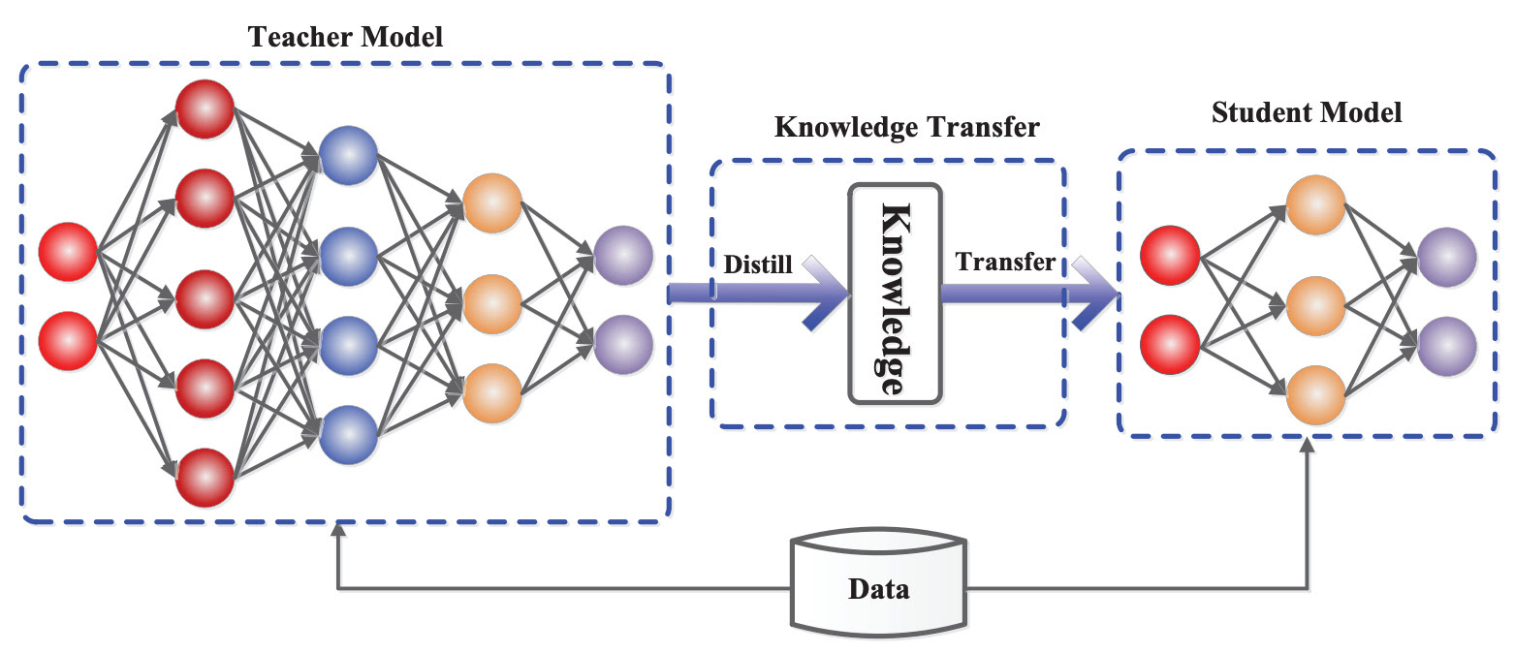
LLaMa catalyzed an explosion of open-source LLM research ==> fine-tunes an LLM over outputs from a more powerful LLM (inspired by knowledge distillation):
- Collect dialogue examples from these models (e.g., using the OpenAI API).
- Perform (supervised) fine-tuning on this data (i.e., using a normal language modeling objective).
Alpaca fine-tunes LLaMA-7B by auto-collecting fine-tuning dataset from GPT-3.5. Cost - $600.
Vicuna fine-tunes LLaMA-13B over 70K dialogue examples from ChatGPT (derived from ShareGPT). Cost - $300.
Koala fine-tunes LLaMA-13B on dialogue examples from Alpaca fine-tuning set + other sources like ShareGPT, HC3, OIG, Anthropic HH, and OpenAI WebGPT/Summarization.
GPT4ALL fine-tunes LLaMA-7B on over 800K chat completions from GPT-3.5-turbo. Authors released training/inference code + quantized model weights for use on CPU.
These models claimed to achieve comparable quality w/ChatGPT and GPT-4. For example, Vicuna is found to maintain 92% of the quality of GPT-4, while Koala is found to match or exceed the quality of ChatGPT in many cases. This impressive performance fostered a promise for open-source LLMs. However, more targeted evaluations of these models reveal that they do not perform nearly as well as top proprietary LLMs like ChatGPT and GPT-4 – they just mimic ChatGPT and trick humans into believing thay are good. The resulting models improve performance on tasks that are heavily represented in the fine-tuning set + pronounced tendency for hallucination.
To make imitation models better in general:
- Generating a much bigger and more comprehensive imitation dataset
- Creating a better base model to use for imitation learning
This was found to yield positive results. Orca - imitation model based upon LLaMA-13B, fine-tuned over higher-quality massiv dataset collected from ChatGPT and GPT-4 (using complex instructions, e.g. CharGPT provides detailed explanations of its response etc., 5M examples from ChatGPT and 1M from GPT-4) ==> Orca performs incredibly well vs. prior imitation models and narrows the gap between open-source imitation models and proprietary LLMs, but it is outperformed consistently by GPT-4. Nonetheless, Orca’s impressive performance reveals that imitation learning is a valuable fine-tuning strategy.

On the other hand LIMA (Less is More for Alignment) – fine-tuning on just 1K examples

Distributed Training
It’s common to train a model using a dataset that doesn’t fit into memory, e.g. medical data (CT scans, genome sequences) or text data (OpenAI) - you need algos for preprocessing, shuffling, and batching data out-of-memory and in parallel - batch size may be small => instability of gradient descent optimization. If even one data sample doesn’t fit into memory - gradient checkpointing = tradeoff to make system do more computation with less memory. Even if a sample fits into memory, checkpointing allows to fit more samples into a batch => train model faster.

Data Parallelism
- Split data on multiple machines (CPUs, GPUs, TPUs)
- Train model on all of them
- Accumulate gradients
Issue – how to accumulate gradients?
a) model updates gradients after all machines finish training: synchronous stochastic gradient descent (SSGD) – slow machines will slow all machines down, especially if there are a lot of workers, but there are many effective algos.
b) model updates weights using the gradient from each machine separately: asynchronous SGD (ASGD) - gradient staleness, when gradients from one machine changed weights before gradients from another machine have come in.
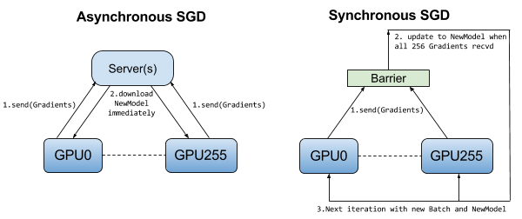
Also, spreading model on multiple machines can make batch size very big. If a machine processes a batch size of 1000, then 1000 machines process a batch size of 1M. Intuitive approach - scale up the learning rate, but LR can’t be too big - unstable convergence.
Master-worker uses a lot more resources than other workers => smaller batch size on the master-worker and a larger ones on other workers.

Model Parallelism
Split model [components] on different machines - machine 0 computes the first two layers, machine 1 - the next two layers, machine 3 - backward pass. Can be confusing - machine 1 has to wait for machine 0 to finish its run.
Pipeline parallelism - machine 1 finishes part 1, passes it to machine 2; machine 2 executes part 1 while machine 1 starts part 2.

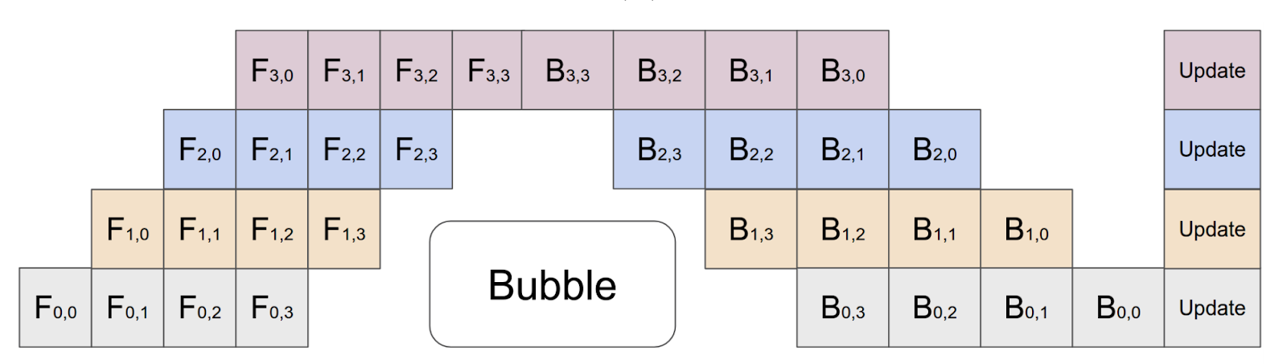
Figure 5-9: Pipeline parallelism for a neural network on 4 machines, each machine runs both the forward pass (F) and the backward pass (B) for one component of the neural network.
Model parallelism and data parallelism aren’t mutually exclusive - many companies use both.

Batch vs. Online [Serving] Prediction
- Batch p.: periodical (hourly, weekly), when don’t need immediate res, saves resources (optimized for higher throughput), example – Netflix movie recommender system. Predictions stored somewhere (SQL or CSV files), retrieved as needed
- Online p. - immediate, on-demand, low latency, example - Google Assistant speech recognition. Traditionally uses RESTful APIs.
Fundamental decision: online or batch? Term is confusing: both can make predictions for a batch of samples or one sample at a time ==> another term: synchronous or asynchronous prediction.
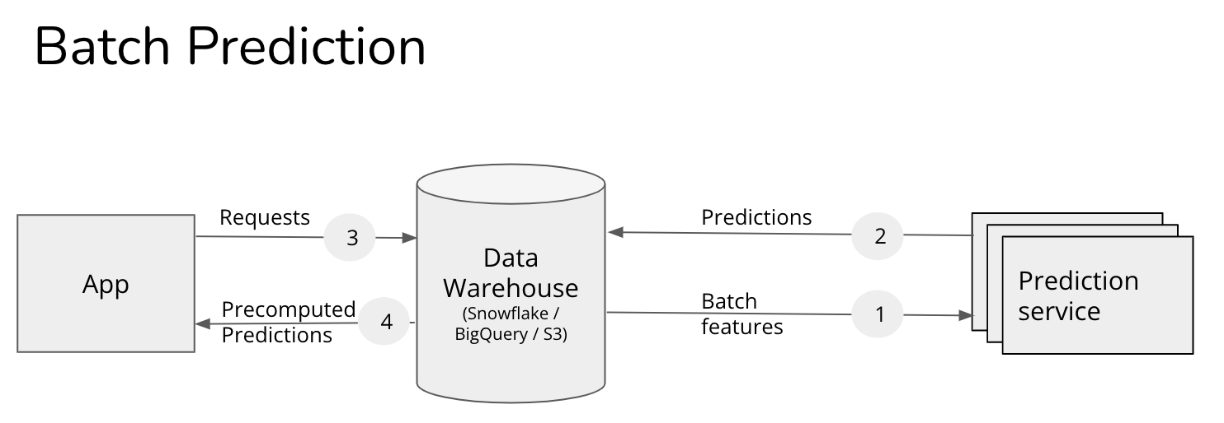

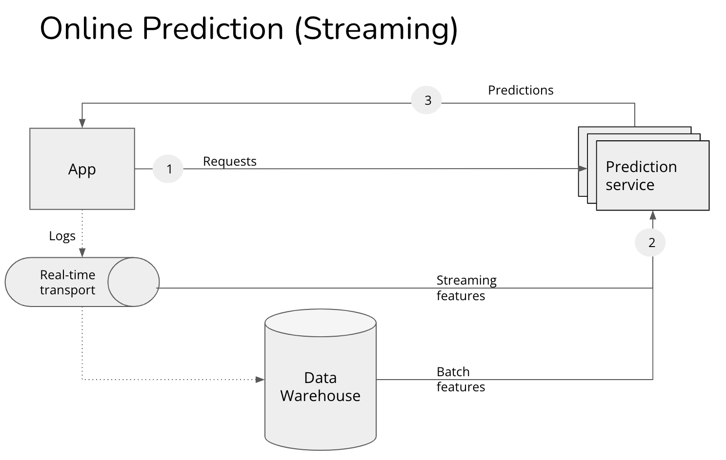
- Batch features: mean meal preparation time in restaurant in the past (historic data)
- Streaming features: # active orders and # delivery people at this particular time. Not always used, sometimes batch features are sufficient

Often, side by side, not mutually exclusive - a) precompute predictions for popular queries, online predictions for less popular queries, b) DoorDash / UberEats use batch p. for restaurant recommendations – takes long, too many restaurants, but use online p. for food item recommendations. Many believe that online p. less efficient (cost and performance) because you may not batch inputs together to leverage vectorization / other optimizations – this is not necessarily true. Online p. - no need to generate predictions for users who are not active (e.g. only 2% users log in daily – huge compute savings).

Model Compression

Low-rank Factorization
Replacing high-dimensional tensors with lower dimensional tensors – e.g. compact convolutional filters: over-parameterized convolution filters are replaced with compact blocks to reduce # params and increase speed. E.g. replacing 33 convolution w/11 convolution in SqueezeNets - AlexNet-level accu on ImageNet w/50 times fewer params. But, this method tends to be specific to certain types of models (CNN) and requires a lot of architectural knowledge.

Knowledge Distillation
Knowledge distillation - small student model is trained to mimic a larger teacher model or their ensemble. Example – DistilBERT reduced BERT size by 40%, but retained 97% of NLU capabilities and is 60% faster. This approach works regardless of the architectural differences betw. teacher and student (student can be RF, teacher - transformer). Disadvantage - if you don’t have a teacher – its training requires a lot of data and time. Method also sensitive to application and model architecture – not widely used in production.

Pruning
Removal uncritical sections of decision tree (redundant for classification). In neural networks, pruning:
- removal of entire nodes of neural network - changing the architecture / reducing # params;
- setting to 0 the least useful params for prediction. Pruning != reducing total # params, but only non-zero params. Network architecture is same. Reduces size of model - more sparse (by over 90%!) and improves computational performance w/out compromising accuracy.
Some argue the value of pruning – why not train a dense model in the first place, but it was shown that a large sparse model after pruning can outperform a retrained small counterpart.

Quantization
Reduces memory footprint, improves computation speed (=reduces training time and inference latency): using fewer bits to represent model’s parameters:
- Default - 32 bits per float number (single precision floating point) => 100M params = 400MB.
- 16 bits = half precision, cuts memory in half (popular: used NVIDIA, Google TPUs for training).
- 8 bits – fixed point or completely in integers (1 int = 8 bits). Not as popular for training, but is an industry standard for inference. Some edge devices support only 8 bits. Most frameworks for on-device ML inference (TensorFlow Lite, PyTorch Mobile) - offer free post-training quantization.
- Extreme case - 1-bit representation of each weight (binary weights).

Types:
- Q during training – training in lower precision (train larger models on same hardware).
- Post-training = trained in single-precision + quantized for inference.

Downsides: your range is smaller => you have to round up and/or scale the values outside the range => rounding errors, and small rounding errors => big performance changes. Risk of rounding/scaling to under-/over-flow and rendering to 0. But major frameworks have this built in.

Cloud vs. edge computing
- Cloud computing: speedy data transfer over network - most queries to Alexa, Siri, Google Assistant
- Edge computing: browsers, phones, tablets, laptops, smartwatches, etc. a) works w/out Internet, b) low latency, c) fewer privacy concerns, d) cheaper

Challenges in Training LLMs
This technology has a great potential for AI apps. But:
- requires millions of dollars for parallel training of the model.
- requires months of training + humans in the loop for fine-tuning.
- requires a huge text corpus + still accusations of using the scraped data illigealy.
- large carbon footprint (training one LLM = five cars in their whole lifetime).

Docker vs. Kubernetes
- Docker – containerization or package, distribute, and run apps in isolated containers on indiv. hosts. Providing lightweight env to encapsulate apps and their dependencies. You manually manage the host, and setting up multiple containers can be complex.
- Kubernetes – orchestrates the deployment, scaling, and management of containerized apps across a cluster of hosts / nodes, automates load balancing, scaling, and ensuring the desired state of apps.

CI/CD Pipeline
Continuous Integration (CI)
Before CI, developers worked independently in silos, and merging things together was chaotic. Solution: pushing changes to the same GIT repo. But with so many people constantly contributing code, things may not always run smoothly, and new errors can emerge. Solution: automate the building / compiling and testing of code changes (unit, functional, integration tests). If tests fail - team is alerted.
Continuous Integration ensures seamless frequent code integration into a shared repository and maintains code quality. It improves collaboration among developers by ensuring all code changes are compatible and free of merge conflicts. Rapid feedback for developers – reduced risk of bugs.
Tools: GitHub, GitLab, Jenkins, and others.

Continuous Deployment (CD)
Follows CI, automates deploy process, auto-deploys all passing builds to prod w/out manual intervention => rapid delivery of updates (features). Benefits: faster release cycles, improved productivity, and enhanced customer satisfaction – rapid delivery of improvements.
Tools: ArgoCD for Kubernetes.

Continuous delivery
Prepares code for prod by transitioning it through multiple test / staging envs (ensuring only stable code is deployed). Difference from continuous deployment - requires a decision to deploy.

MLOps
- Increases productivity through automation and standardization
- Ensures reproducibility through data and model versioning
- Reduces costs by minimizing manual tasks and improving model management
- Improves monitorability by allowing continuous model retraining and monitoring for data and model drift.

MLOps Tools
- CICD: Jenkins, TravisCI, and CircleCI - automate integration and deploy of code changes
- Containerization and Orchestration: Docker, Kubernetes, OpenShift - help package and deploy ML models.
- Model Management and Versioning: MLflow, DVC, Neptune - version control and collaboration on ML models.
- Monitoring and Logging: TensorBoard, Grafana (analytics and interactive visualization web app), ClearML, and ELK Stack - monitor performance and health of ML model.
- Data Management: Apache Airflow (workflow management), AWS Glue (data integration), Apache Nifi (data flow automation) - automate data collection, preparation, and storage.
- Infrastructure Automation: Terraform, Ansible, Puppet – automate provisioning and configuration of infrastructure.

Additional Resources

- More about ICL here: https://a16z.com/2023/05/25/ai-canon/ - see Practical Guide to Building w/LLMs => Building LLM applications for production by Chip Huyen, etc.
- LLMs System Design: https://medium.com/analytics-vidhya/machine-learning-system-design-interview-cheat-sheet-llms-part-4-90753072682b (requires small-fee Medium subscription)
- LLM Patterns: https://eugeneyan.com/writing/llm-patterns/
- http://patrickhalina.com/posts/ml-systems-design-interview-guide/
- https://research.google/pubs/pub46555/
- https://stanford-cs329s.github.io/syllabus.html
- Architecting ML pipeline: https://towardsdatascience.com/architecting-a-machine-learning-pipeline-a847f094d1c7

